Index Page

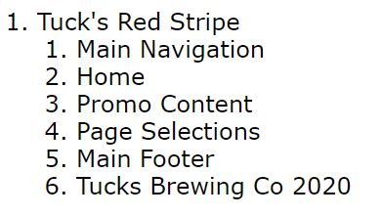

Promo Page

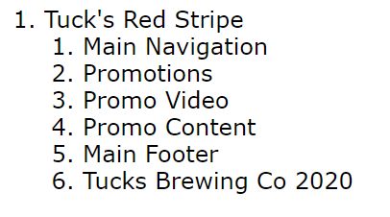

Product Page

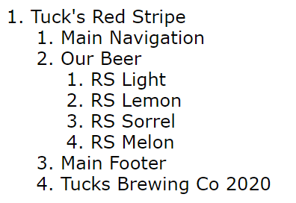

About Page

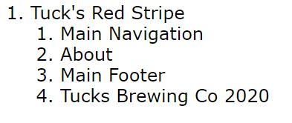

Contact Page

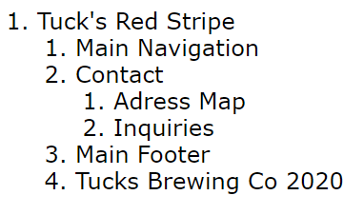

**Dimensions**

Static width – 1166px

Hero content is 100%

Logo – 300x200

Title and Navigation boxes – 80px

Large margins - 80px

Small margins – 40px

Most content is 400px or 300px tall

Promo - 2/3s is picture 1/3 text